**SAMUEL GANAM IT CENTER**



**Human Resource Management System**

Functional Requirement Specification

Version 1.2

**Document Number:** SGIC/HRS/FRS/Doc-001

**Owner:** Sinthuja Vijayarajah

**Effective Date: 03.10.2018**

**Approval**

|  |  |  |  |  |
| --- | --- | --- | --- | --- |
| Department | Name | Role | Approval by (Signature) | Date |
|  |  |  |  |  |
|  |  |  |  |  |
|  |  |  |  |  |
|  |  |  |  |  |
|  |  |  |  |  |
|  |  |  |  |  |
|  |  |  |  |  |
|  |  |  |  |  |

**Revision History**

|  |  |  |  |  |
| --- | --- | --- | --- | --- |
| Revision | Date | Status | Revised by | Revision details |
| V1.0 | 12.09.2018 | Initial draft with Leave management system functionalities |  |  |
| V1.1 |  | Draft with employee management & PAR scope included |  |  |
| V1.2 | 03.10.2018 | Drafted based on finalized org.structure |  |  |
|  |  |  |  |  |
|  |  |  |  |  |
|  |  |  |  |  |

**Table of Contents**

1. Introduction 5

1.1. Objective 5

1.2. Scope overview 5

1.3. References 6

2. Assumptions and Dependencies 6

2.1. Assumptions 6

2.2. Dependencies 6

3. User Groups 7

4. Functionalities 8

4.1.1. Employees 9

a. Employee Management 9

# **Introduction**

## **Objective**

The objective of this document is to explain the implementation and business rules of the proposed “Human Resource Management System” for *Samuel Gnanam IT Center*. The document addresses the functional requirements, nonfunctional requirements, constraints, possible use cases and dependencies of the system.

This document is proposed as an input and reference for the architectural designing process of the system. The document can be referred by the involved users, developers and quality testers for further details regarding the system.

## **Scope overview**

HR tasks are too complex and time-consuming when performed manually. Leveraging the help of a technological solution like an HRMS can help organization save time, cut costs, and manage resources better.

Based on the organizational structure user groups are mainly categorized under 4 main groups and each user groups have different user roles and user rights. The main 5 user groups are

1. Admin
2. Employees
3. Trainers
4. Trainees
5. External users

System functionalities are mainly aligned according to the user groups. Below diagram illustrates the main modules of the system based on the user group.

## **References**

Inputs for the system requirements were collected from the system users from the relevant departments (HR department, Finance & Accounting, Administration). Functionalities and system requirements were refined via continuous team discussion and brainstorming.

# **Assumptions and Dependencies**

## **Assumptions**

N/A

## **Dependencies**

N/A

# **User Groups**

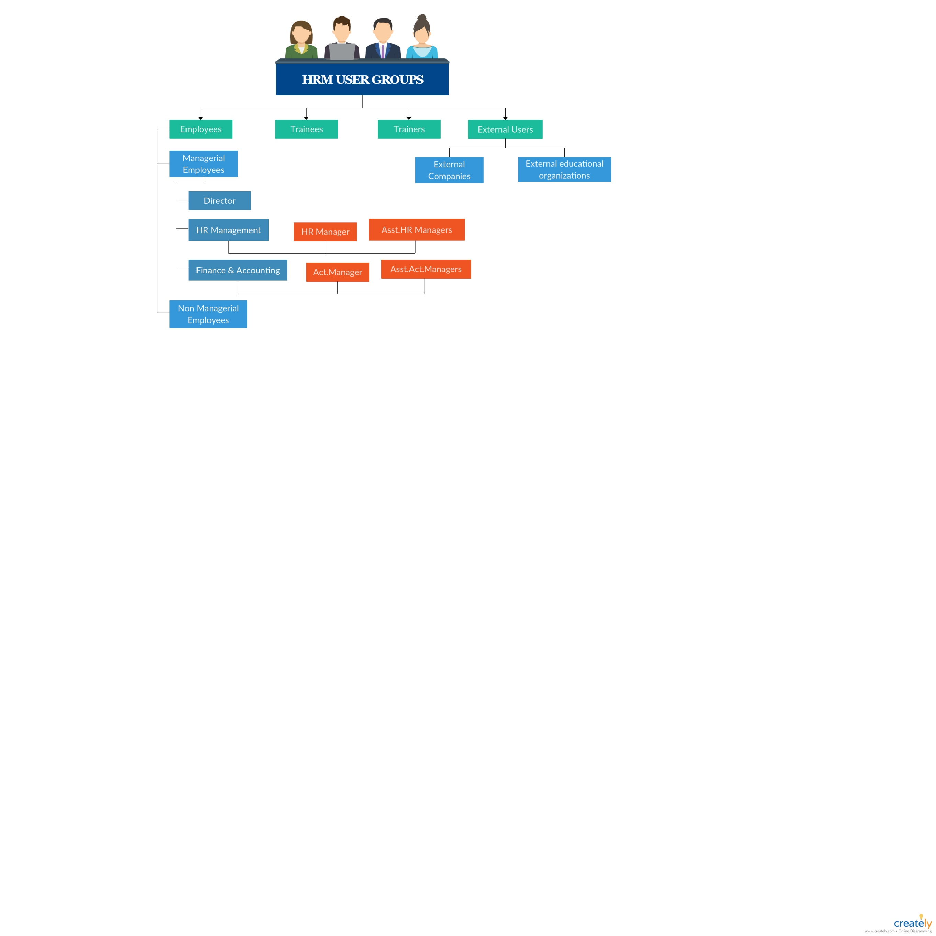

# **Functionalities**

Functionalities are described to individual modules based on the core design of the organization. The core design of the organization is illustrated in the attached picture.

[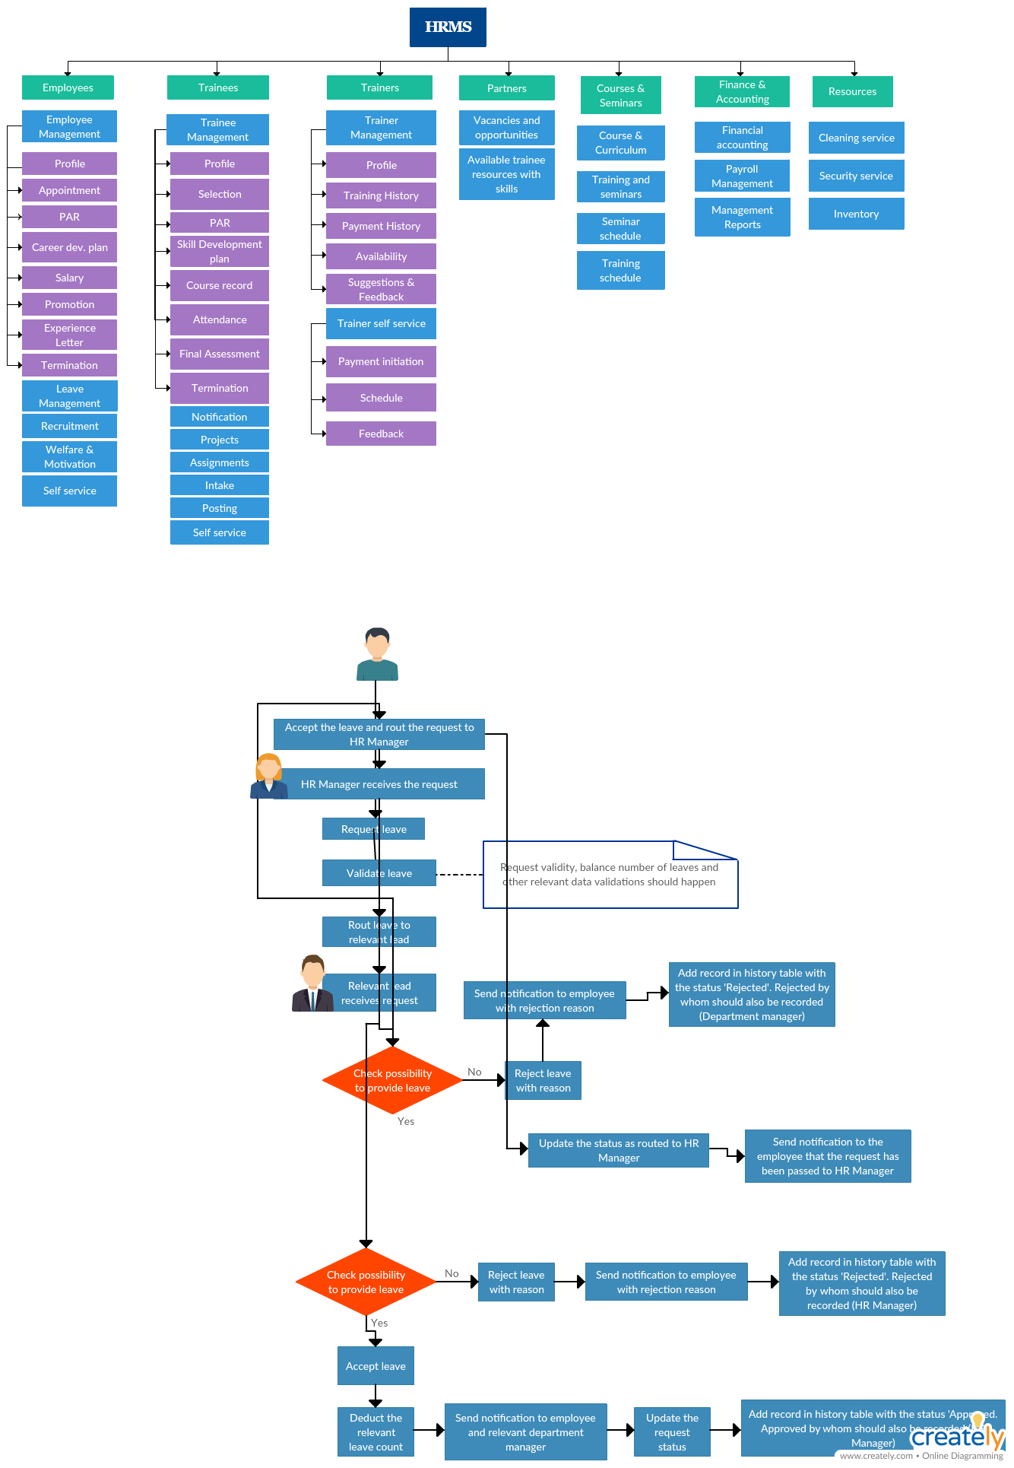](Images/Orag%20(1).jpg)

## **Employees**

### **Employee Management**

1. ***Profile***

Below tabs should be available to view & manage relevant information

* Profile
* Personal file (Birth certificate, Police report, Educational certificates, appointment letter, service letter, resignation letter, termination letter, etc.)
* Leaves
* PAR
* CDP (Career development plan)
* Remuneration
* Promotion
* Termination

1. ***Appointment***

* Add new profile for employee
* Add required information to the profile (personal file attachments & basic information)
* Assign roles & responsibilities
* Set remuneration
* Add allocated leaves
* Schedule PAR review for the probation period
* Schedule career development plan

Appointment:

Adding new profile - information to fill

* NIC
* Name (first name and last name)
* Date of birth
* Gender
* Nationality
* Religion
* Address
* Contact no.
* Email id
* Educational qualification
* Professional qualification
* Skills
* Experiences
* Position
* Salary
* Appointment date

Attachments:

Basic:

|  |
| --- |
| Job application |
| Source of recruitment |
| Cv |
| Nic certified copy |
| Birth certificate |
| Marriage certificate |
| Job offer letter |
| Job description |
| Agreements and contracts |
| Letter of job acknowledgement |
| Proof of educational and professional qualifications |
| Interview marks and results |
| Medical report ( medically fit for work) |
| Salary, epf etf and other details |
| Salary increment with details |
| Other letters and documents exchanged |
| Complains and complains from customers and coworkers |
| Promotion letters |
| Monthly etf statement |
| Appraisal |
| Pre-employment and appointment docs including offers of employment |
| Leave applications, notes on attendance or tardiness |
| Forms relation to employee benefits |
| Forms providing next of kin and emergency contacts |
| Awards and citations of excellent performance |
| Warnings and other disciplinary actions |
| Docs relating to departure from the company |

Extra:

Special performance

Highlights

Games and athletics performance if any

1. ***PAR***
2. 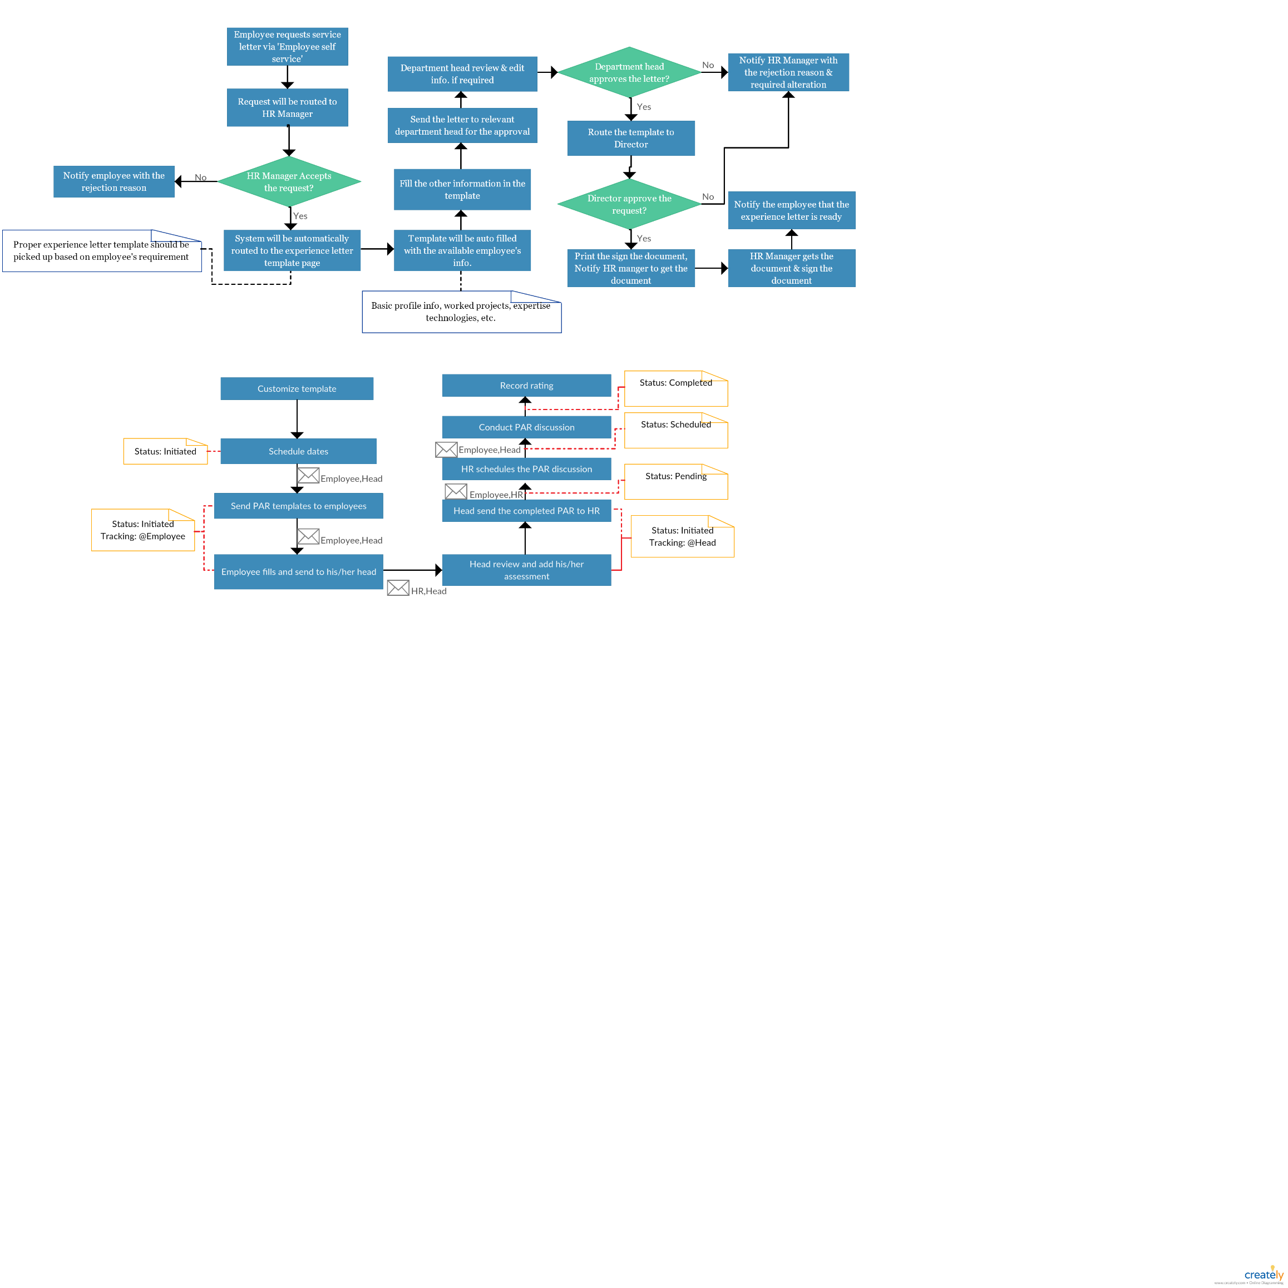*PAR Review for a non-managerial employee*
3. *PAR Review for a managerial employee*

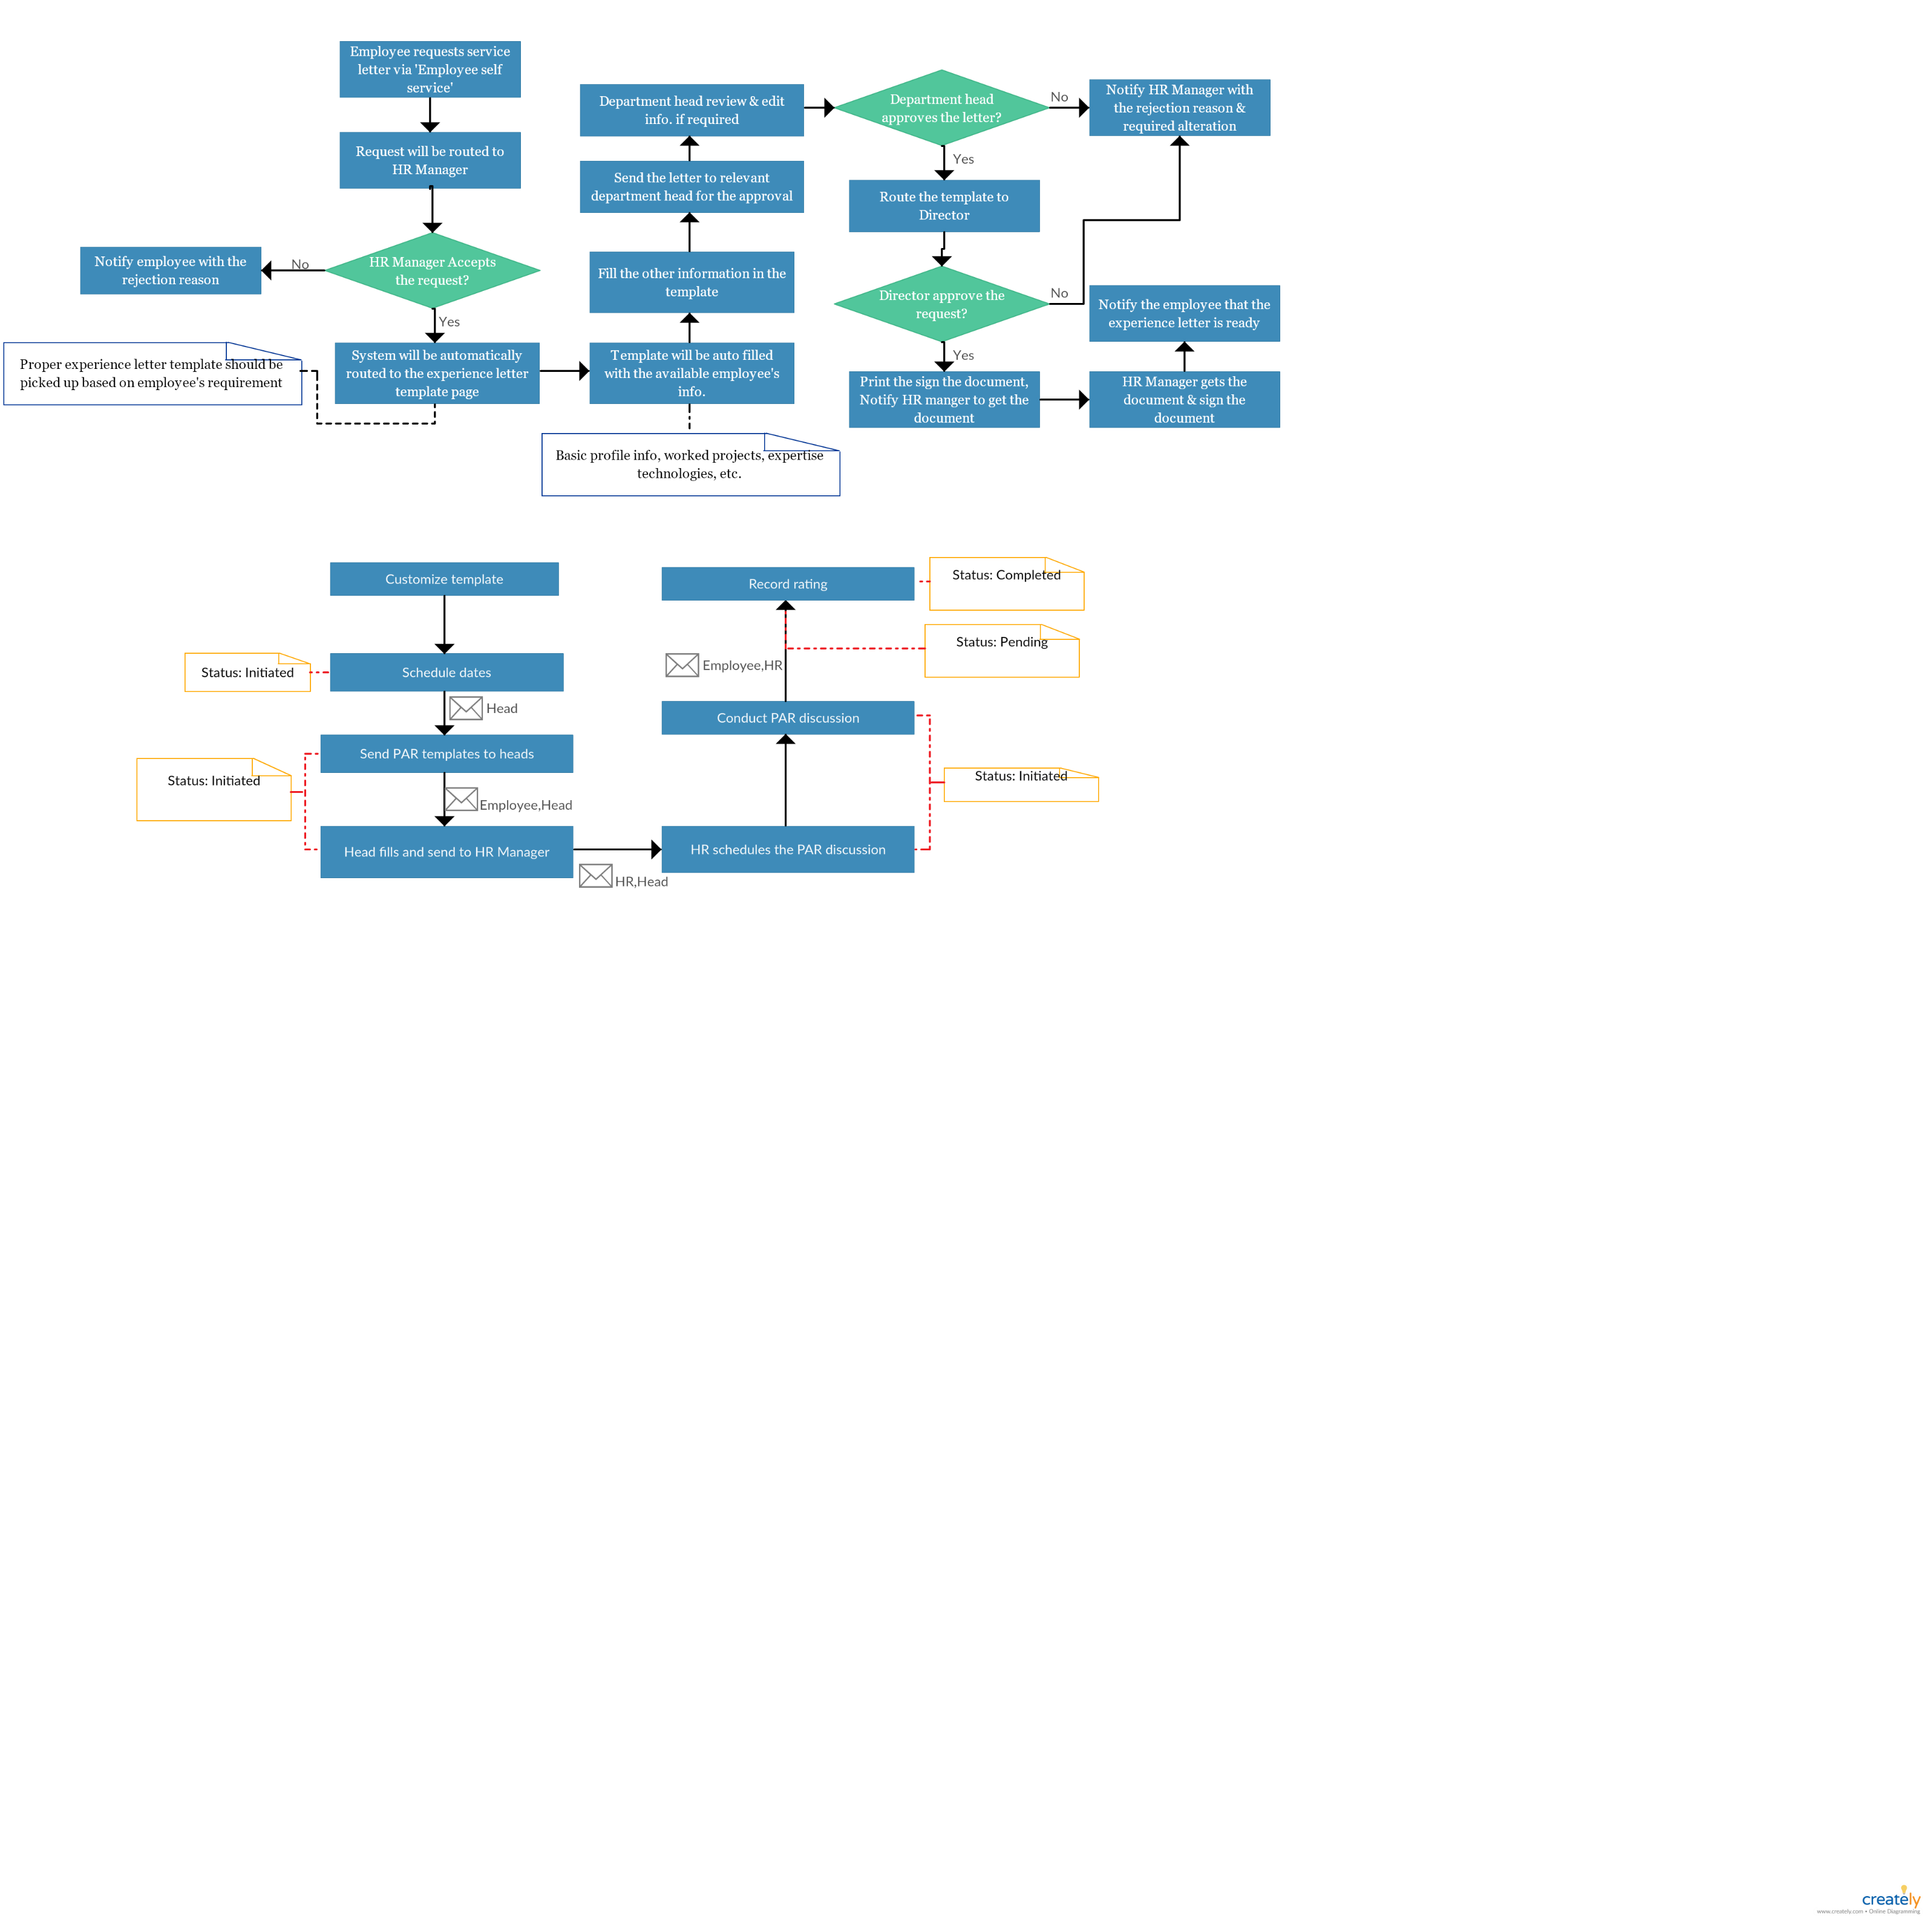

1. **Career Development plan**

Based on the PAR review records, years of stay in the company, years of experience and educational qualification management will decide the career development plan for each employee. Career development plan will include trainings, financial support for further professional studies

HR Manager should able to record the relevant employee’s development plan and the relevant employee should able to view his/her planned career development plan.

1. **Salary**
2. *Salary Increments*

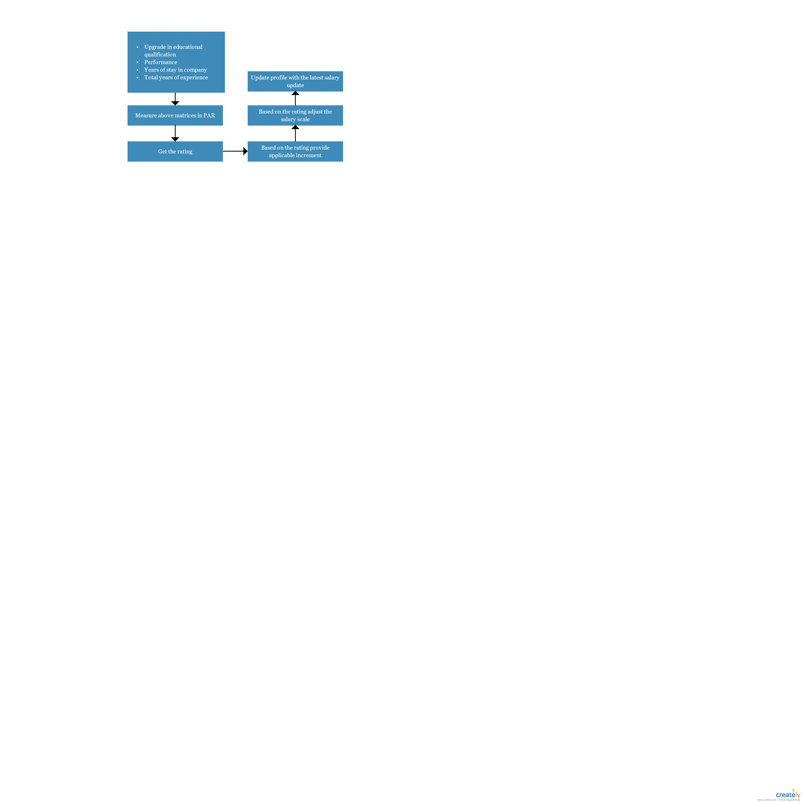

**

1. **Promotion**

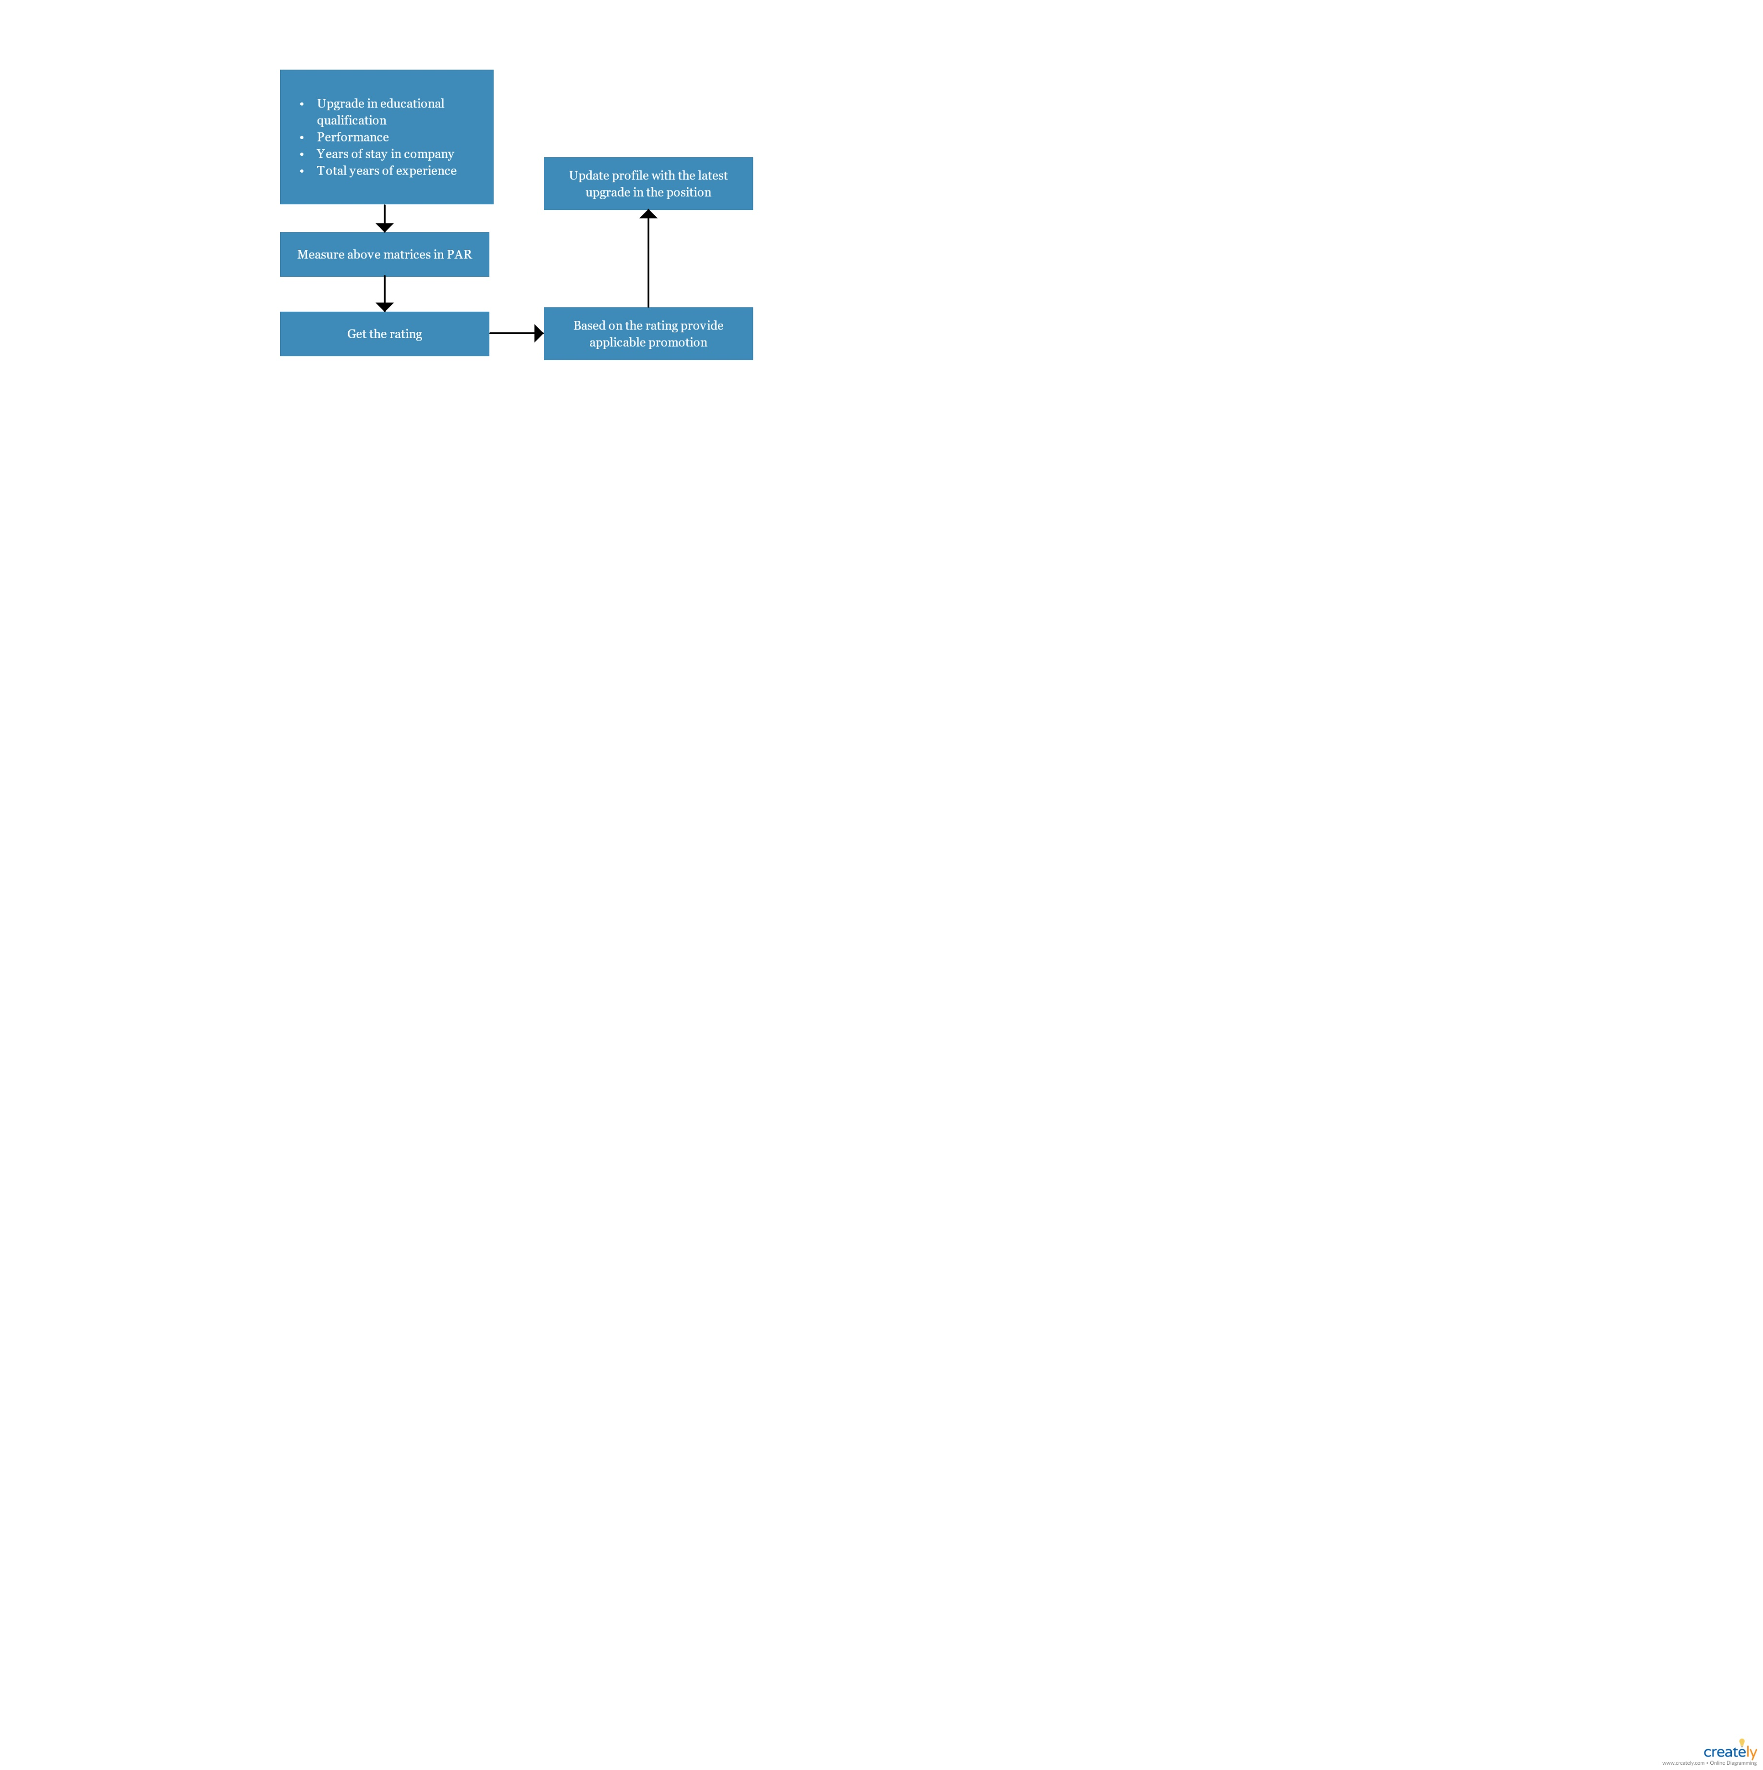

1. **Experience letter**

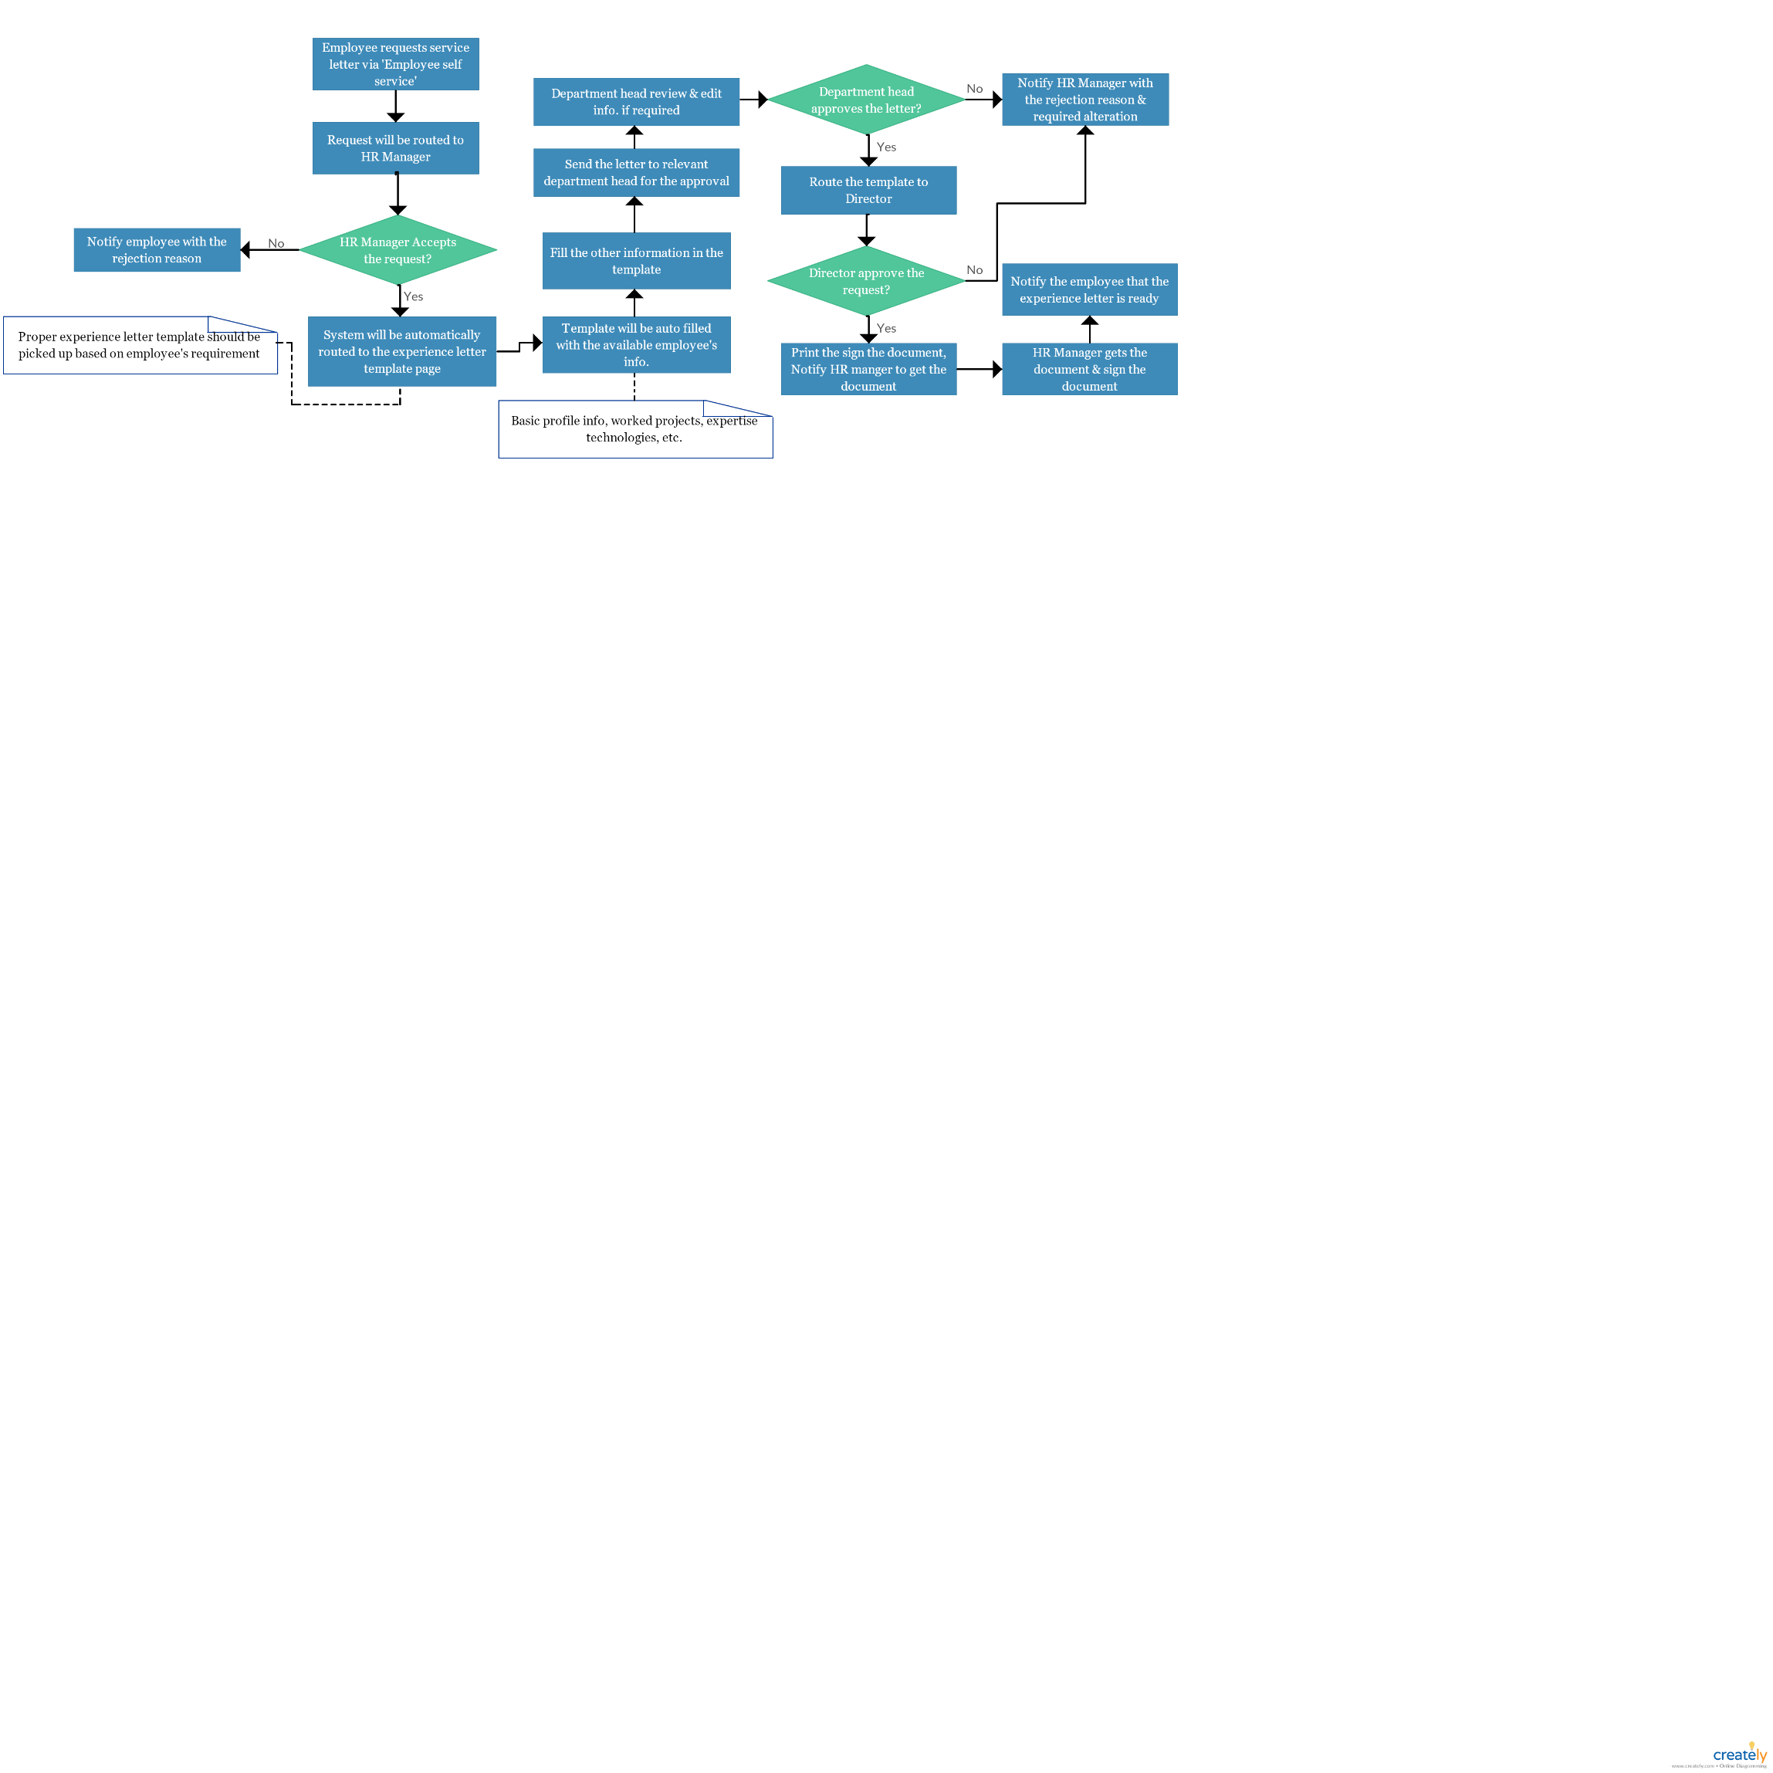







1. **Termination**
2. *Termination initiated by department manager*

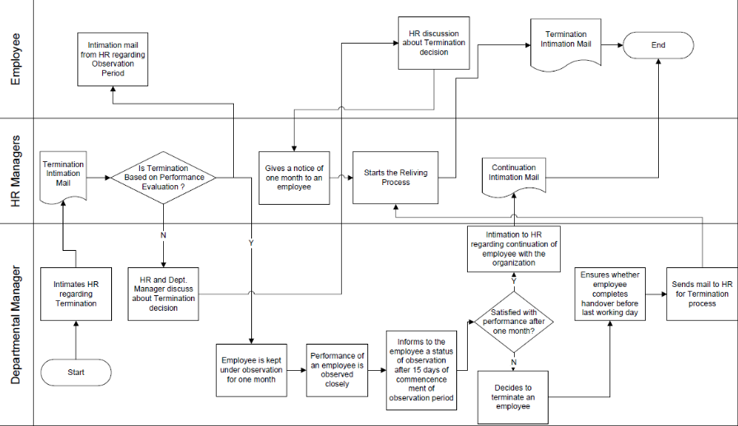

1. *Termination via resignation*

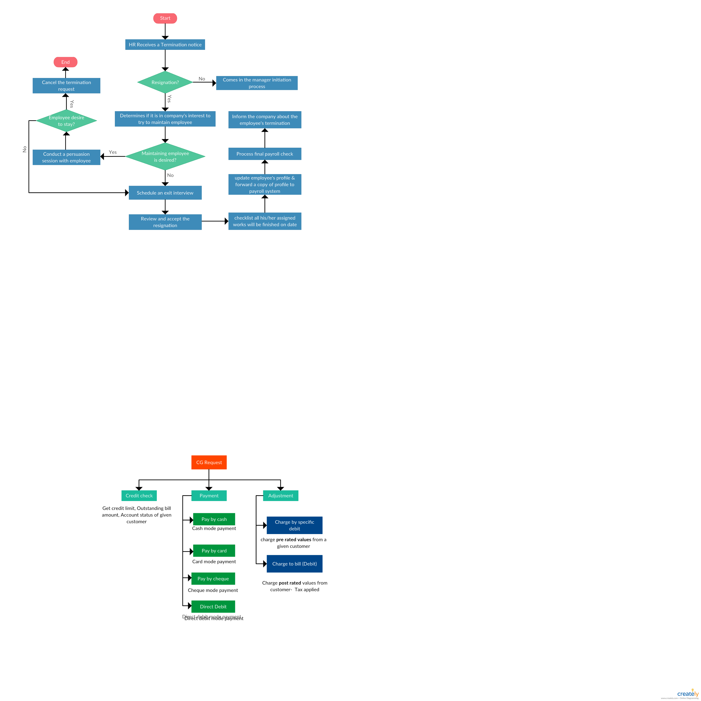

1. **Leave Management system**

Primary users of the Leave management module will be the employees. There will be four user levels.

1. Admin
2. Director
3. HR Manager
4. Accounts Manager
5. Engineering Manager
6. Employees

Based on the user level functional requirements are categorized below.

1. **Admin**

Admin should have the functionality to add more users to a specific user group also should be able to create a new user group on request.

Should have the access to the archived data.

1. **Director**

There should be a functionality to view the number of employees who are on leave while selecting a specific date on the calendar.

Director should be able to search for a specific employee with the employee id and view below information

1. Total number of leaves
2. Utilized number of leaves
3. Number of leaves in balance

Leave requests from the managerial employees should be routed to director, and the approval should be sent to both HR Manager and employees. Leave status changes and leave balances should be updated there itself.

1. **HR Manager**

While navigating to the Leave management dashboard, there should be a notification bar to show all the leave requests

While viewing the leave request below information need to be displayed from the relevant leave request

* Dates on which the leaves are requested
* Number of days requested for leave
* Leave reason
* Available leaves in balance
* History of leaves taken till date
* History of leaves rejected

There should be options to accept or reject the leave request. Also, there should be a place where the HR Manager could enter the rejection reason while rejecting the leave request. A notification should be sent to the employee and the department lead while accepting or rejecting the request.

There should be a calendar view where the HR Manager can see the details of the employees who are on leave while selecting the specific day. This view will help the HR Manager in measuring the hindrance while providing leaves for employees specially in same department.

A different notification is required to see the lieu leave recommendation from the respective leads of employees. Lieu leave request should have the recommendation of the lead, employee detail from whom the lieu leave request came, number of days to be added as lieu leave, leave history of the specific employee.

Lieu leave request should be routed via the respective department manager. Lieu leave request requires options to either accept or reject. While rejecting the request a notification needs to send to the respective lead and employee with the rejection reason. While accepting the request lieu leave count should be added to the respective employee and an acceptance notification needs to be sent to the relevant department manager and employee.

There should be a notification to view the ‘Leave carry forward request’, where the HR Manager could see the leave carry forward request from the employee. This request should have the relevant employee details including the number of leaves requested to carry forward.

The request should have the option to view the employee’s leave history and total available balance leaves. Also, it should have the option to either accept or reject the request. While accepting the request number of leaves requested to carry forward should be added to the respective employee. A notification should also be sent to the employee. While rejecting the request a rejection reason should be sent as a notification to the employee.

1. **Employee**

Employee should have the option to view the leave details in the dashboard

* Total number of leaves
* Number of medical leaves
* Number lieu leaves
* Number of Annual leaves
* Number of utilized leaves
* Number of leaves in balance
* Statuses of each leave

Employee should have the option to view the leave history details with the leave status, leave type, date and number of days of a leave.

Employee should be able to send a leave request. Leave request form should include the below details

* From to Date
* Based on from and to date, number of days should be calculated automatically
* Should show the number of available leaves in balance
* Leave request reason
* An attachment field where any documents could be attached if necessary (Medical reports)

lieu leave request and leave carry forward request should be available. Both requests should be routed to the HR Manager via the respective department manager

There should be a calendar view where the employees can see the holidays and company leaves

**Security requirement**

User levels should be specified accurately so that the accesses to the relevant sensitive information could be secured.

**Facts and Constraints**

* Leave types

1. Annual leave
2. Casual leave
3. Special leave
4. Medical leave
5. Short leave
6. Half day leave
7. Lieu leave

* Leave counts (permanent employee)
  + Casual leave: 7 days per year
  + Annual leave: 14 days per year
  + Medical leave: 14 days per year
  + Half day: 2 per month
  + Short leave: 2 per month
* If an employee requests annual leave more than the number of leaves he is eligible of should request the rest number of leaves as special leave.
* Medical report should be attached for the medical leave requests which are more than 3 days
* Annual leaves are not applied for the first year of the employment period to an employee
* On the first year of employment period an employee will gain ½ day casual leave on the completion of each month. At the end of the year the employee will earn 6 days of casual leave.
* All the leave requests from the managerial employees should be routed to the director & HR manager should be notified on the request approval
* Other employees leave request should be routed to the HR manger via the relevant department manager. Both the employee and respective department manager should be informed on either request approval or rejection.

**Possible use cases**

Employee requests medical leave more than 3 days

Employee requests annual leave more than 7 days

Managerial employee requests leave (should be routed to director)

Employee requests half day

Employee requests lieu leave

**Sample work flow**

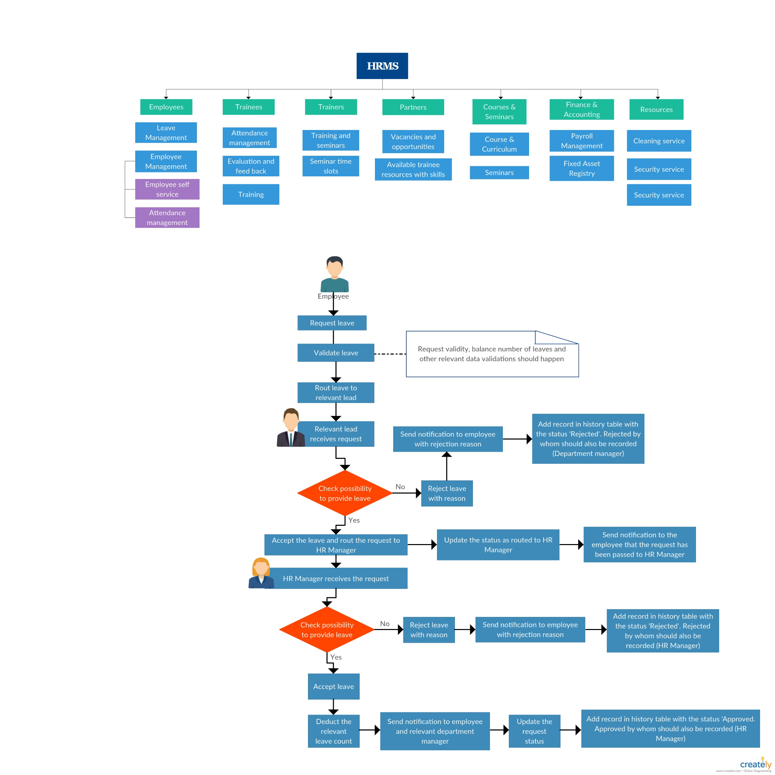Use case: An employee request casual leave

1. 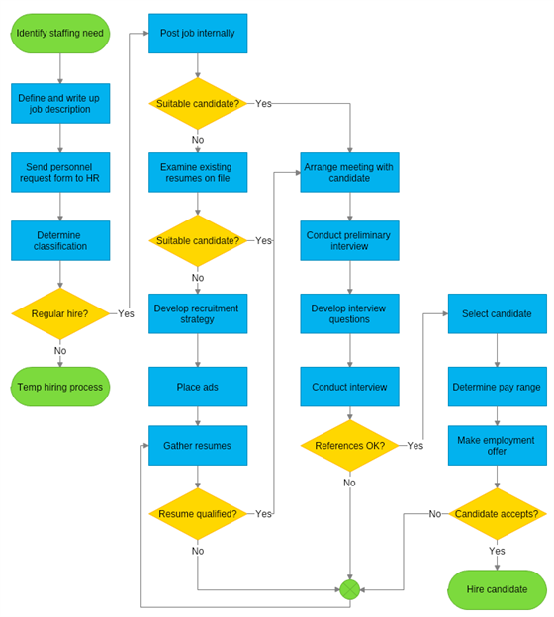**Recruitment**
2. **Welfare and motivation**

* Employee should be able to view the available welfare details
* HR Manger should create a welfare event
* Employee should be able to view the welfare event details which have been taken place in the company

1. **Employee Self service**

Below menus should be available for an employee

* Complaints and feedbacks
* Requests (Experience letter, welfare, copies of certificated, etc.)

## **Trainees**

### **Trainee Management System**

### ***Profile***

* Basic profile details
* Attachments (Birth certificate, Police report, Educational certificates, etc.)
* Leave History and Leave details
* PAR Review Details
* Rating details
* Workplace & Track preference

1. ***PAR***

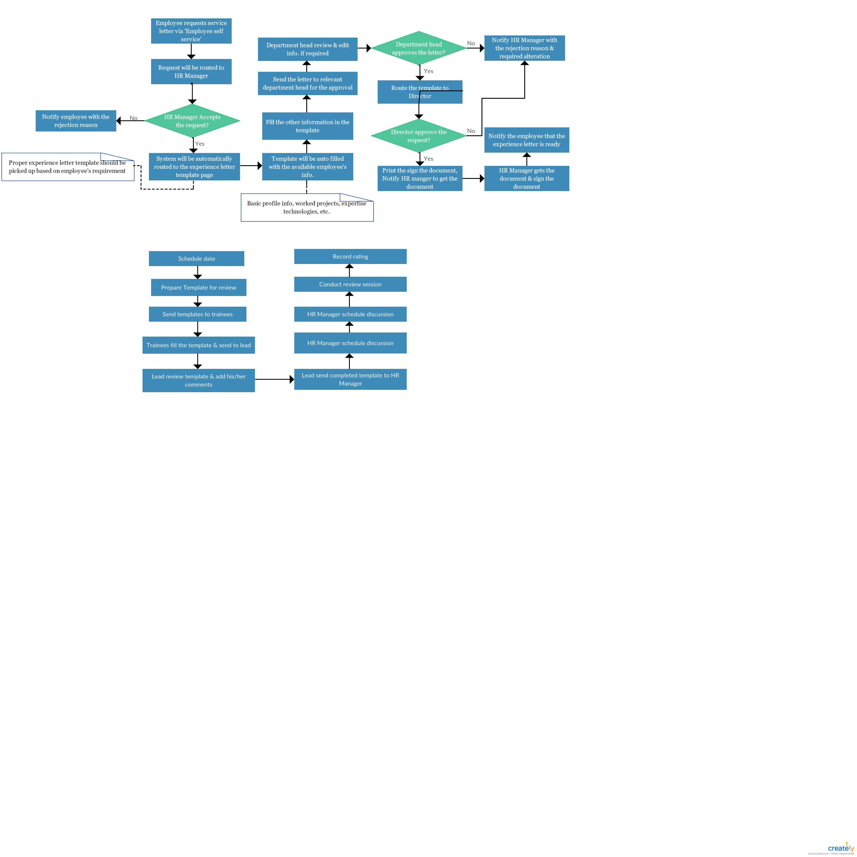

1. ***Skill Development Plan***

Skill development plans are scheduled based on the assignment scores and PAR outcomes. Relevant trainee and respective lead will be informed regarding the development plan.

1. ***Course record***

Should be able to plan and update course content. At the end of specific module, that module should able to be updated as ‘’Done’.

1. ***Attendance***

An excel sheet should able to be imported and based on the excel sheet attendance data should be extracted

Every week the attendance percentage should be calculated and below reports should be generated (These reports should be printable)

The attendance percentage will be calculated based on the below matrix

**Monday to Friday:** Students could stay any time and the attendance percentage should not be less than 80%

**Saturday & Sunday:** Attendance will be counted only during the period of 8.30 a.m. to 5.30 p.m. Student should gain minimum 80% of attendance during the weekend.

* Number of student’s vs attendance percentage
* List of students low than 80% attendance
* Monthly report for attendance with percentage against student’s name

The students who don’t have the 80% attendance should be notified stating their low attendance percentage. The report containing the attendance for a week with the attendance percentage should be mailed to the trainees at the end of week.

1. ***Final Assessment***

Scores for assessments should be recorded for each trainee and that should be queried by entering the trainee id

This tab can be used to search for the eligible candidates, and candidates should able to be filtered using the rating, desired working location.

1. **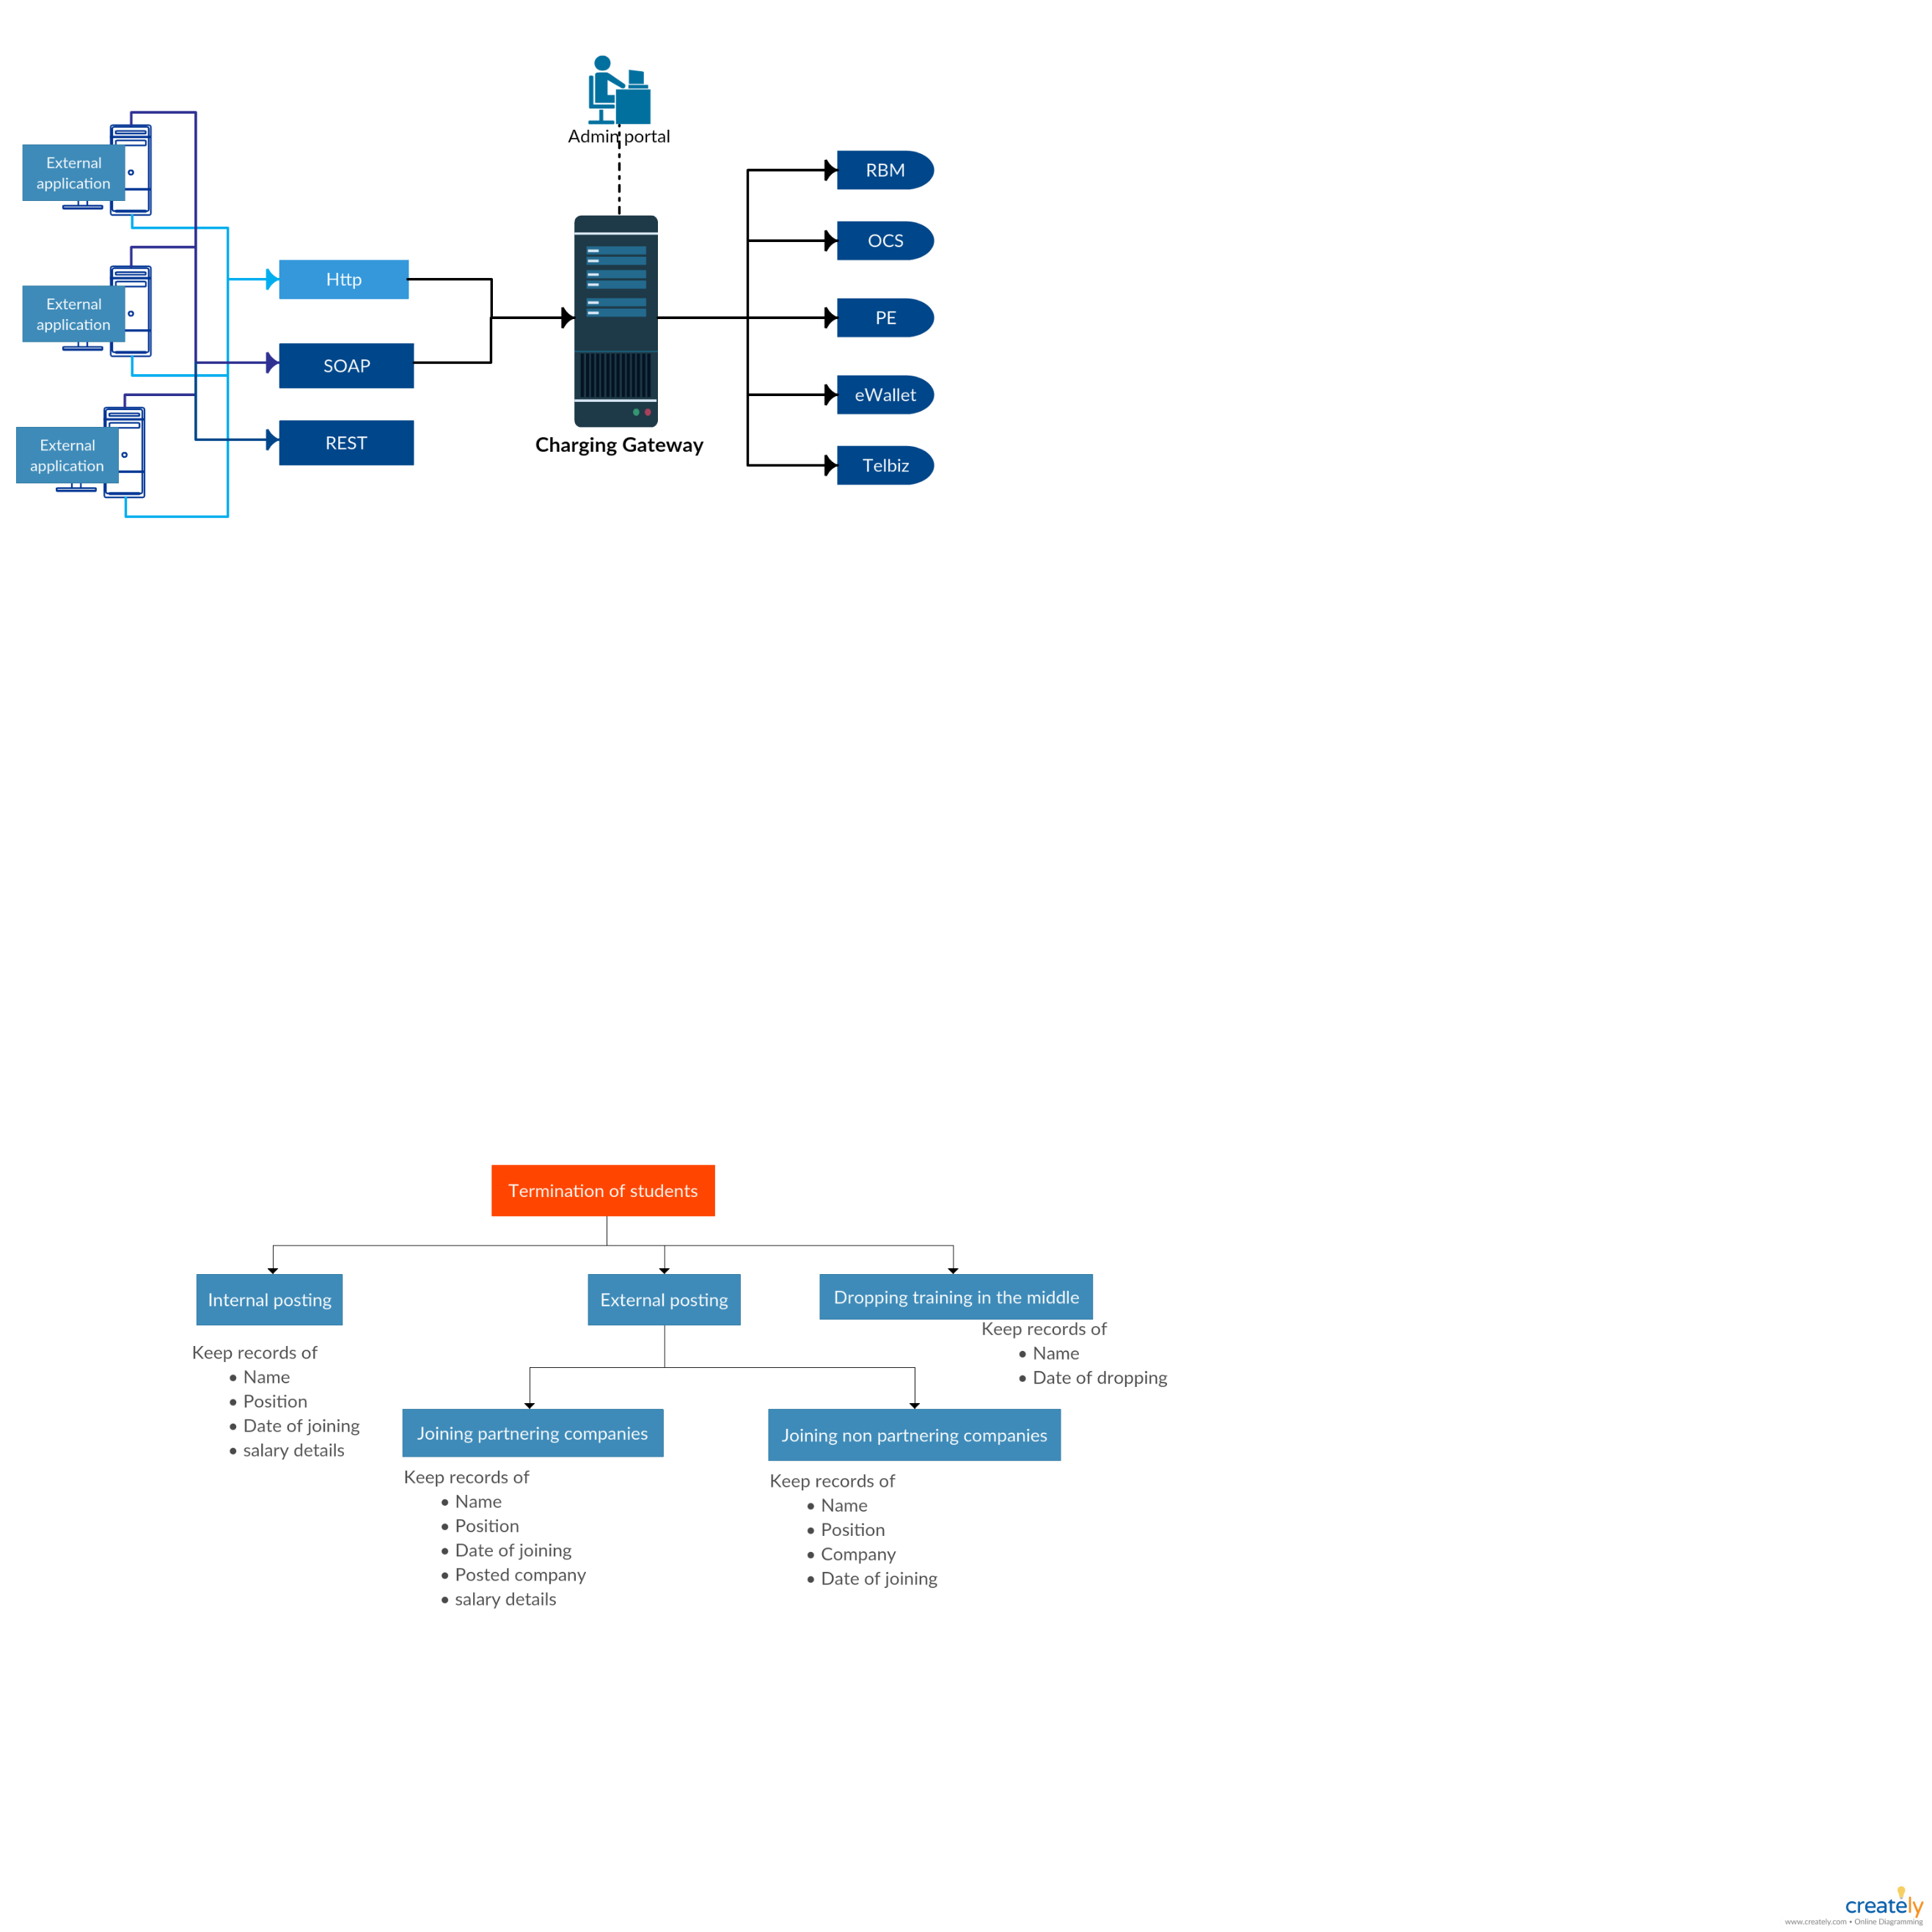*Termination***

### **Notification**

There should be notification to students via SMS & email to the below scenarios

* Class cancellations
* Changes in training schedules (Time change, Trainer change, Topic change)
* Assignment deadlines
* PAR deadline
* Notifying the lower attendance

### **Projects**

* Should be able to create new projects with the project description
* should bale to upload required files for the project
* Trainees should able to view all the ongoing and completed project details
* All the updated FRS for the projects should be available.
* Relevant github links will be available for the projects
* Trainees can record their daily activities on the projects

### **Assignments**

* New assignment tasks should be up loadable
* Relevant documents should be up loadable
* Students should able to upload their completed assignments
* Deadline for the assignments should be handled
* After the assignment correction, trainees should be able to view their scores

### **Intake**

### **Posting**

By selecting the batch, there should be a way to view their below posting details

* Trainee’s Name
* Posted Company (Should differentiate the partnering companies & non-partnering companies)
* Posted date
* Still in the employment state?
* Posted Track (QA/Development)
* Salary

### **Self service**

Below tasks should able to be done via self service

* Complaints
* Requests

## **Trainer**

### **Trainer Management**

1. ***Profile***

Below tabs should be available for a trainer profile

* Basic details
* Experiences
* Expertise technologies

1. ***Training History***

Should able to view all the completed training details. This view should contain the date the training took place, training topic and the number of trainees participated. This view is specific for the trainer

1. ***Payment History***

* Should keep the record for the trainer’s payment.
* Each payment initiated should come under this list & the relevant status should be updated accordingly

1. ***Availability***

Should able to view the availability of a trainer for the training session. This should also be updated by the time the trainer schedules the training session.

1. ***Suggestion & Feedback***

Should able to view all the feedbacks & suggestions from the specific trainee & the feedback & suggestions from trainees to the specific trainer

### **Self Service**

Trainee self service should have the options to do the below functionalities

* Initiate training payments
* Schedule a training session
* Provide suggestions & feed backs
* View payment history
* View status of an initiated payment
* View history of all the training sessions conducted with the covered topics

## **Partners**

### **Vacancies & Opportunities**

External partners should be able to post the available vacancies and opportunities in their companies. The vacancy details will contain their requirement, expected number of resources needed, the date they expect the resource to the joining.

### **Available trainee resources with skills**

External partners should able to view the below details of our available trainee resources.

* Names
* Final Rating
* Desired Track
* Desired location for the work
* Curriculum vitae up to date

The above details should be filterable

## **Courses and Seminars**

### **Courses and Curriculum**

The tab should have all the details of our courses and curriculum

This should be updateable and new items should bale to be added

### **Training**

The tab should contain the details of all the training sessions planned. This should also be updatable. The training should have the details of topics to be covered and resource person for the training

### **Seminar**

The tab should contain the details of all the seminar sessions planned. This should also be updatable. The training should have the below details

* Planned number of seats for the session
* Resource person
* Topics to be covered

### **Seminar Schedule**

This should be a calendar view to view all the planned seminar details with date and time

### **Training Schedule**

This should be a calendar view to view all the planned training session with date and time

## **Finance and Accounting**

1. **Financial Accounting**
2. ***Trainer Payment***

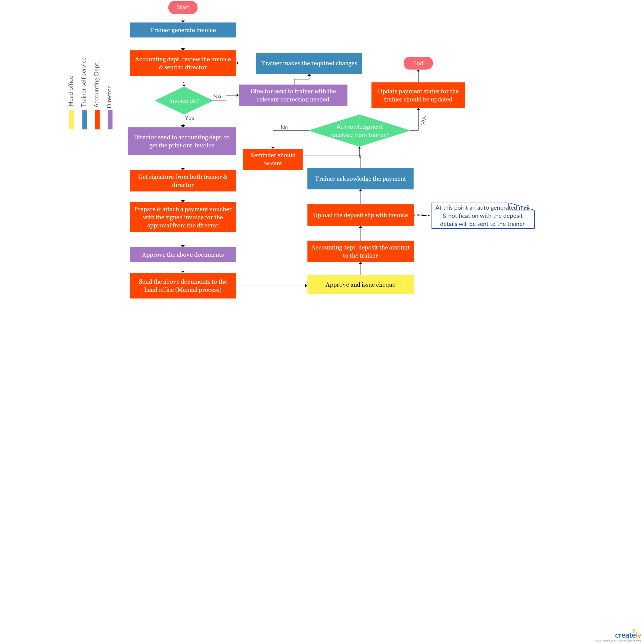

1. **Capital expenditure**

